***Git Commands***

git clone command:

* git clone command is used to create a copy of existing git repository. And it downloads all the repository’s files, branches and commit history from remote source to a local machine

cd command:

* cd command is used to change the directory

git add command:

* git add command is used to stage changes before committing them to a git repository. It adds modified or new files to the staging area.

git commit :

* This commit is used to save staged changes into the repository with a message describing what was changed.

git push:

* This command is used to upload the local commits from your git repository to a remote repository like github.

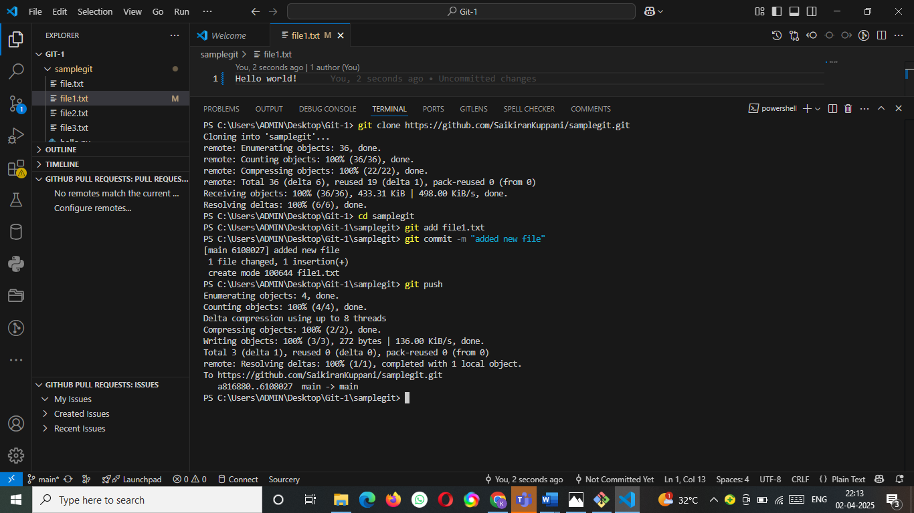

git pull command:

* This command is used to fetch and merge changes from remote repository into your local repository. And it keeps your local repository up to date with the latest changes made by others.

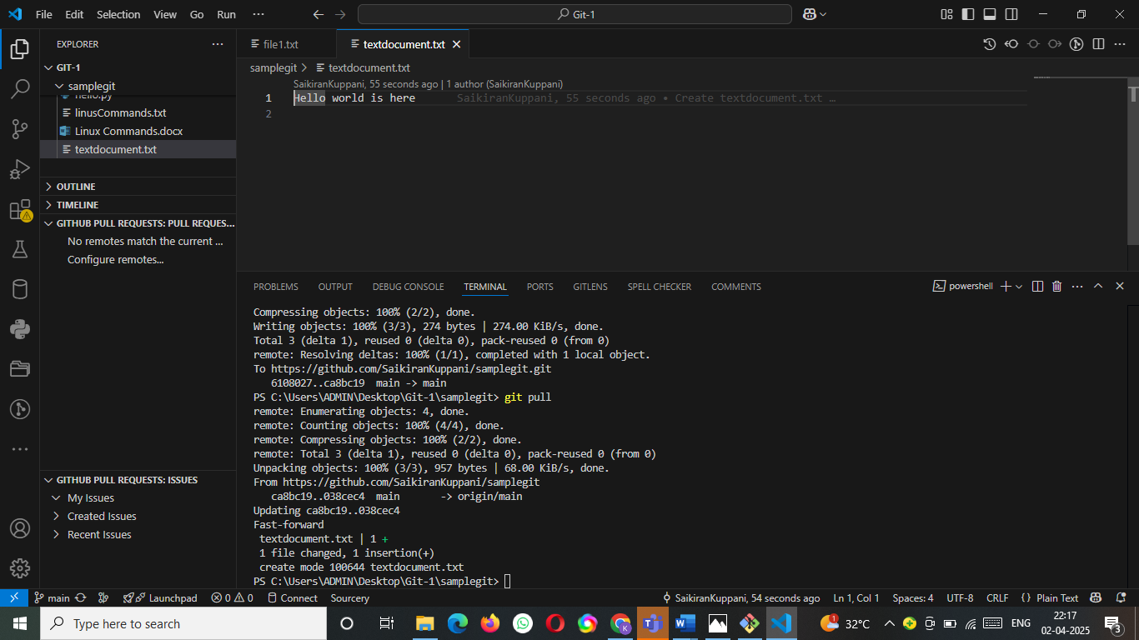

git branch:

* This command is used to list the branches and current working branch

git checkout:

* This command is used to switch branches or restore files in git. It’s commonly used to navigate between different branches or revert changes.

git init:

* Git init command is used to is used to initialize a new Git repository.

